USN | 1 | M | S
M S RAMAIAH INSTITUTE OF TECHNOLOGY
(AUTONOMOUS INSTITUTE, AFFILIATED TO VTU)
BANGALORE – 560 054
MAKEUP EXAMINATIONS – JULY 2016

Course & Branch | : | B.E. – Electrical & Electronics Engg. | Semester | : | VI
Subject | : | Linear Integrated Circuits | Max. Marks | : | 100
Subject Code | : | EE604 | Duration | : | 3 Hrs

Instructions to the Candidates:
- Answer one full question from each unit.
- Typical standard values of Resistors and Capacitors sheet allowed.
- Suitably assume the missing data if any.

 |  |  | UNIT – I
1. | a) |  | Two signals which each ranging from 0.1 to 1 V are to be summed and amplified by a factor of 5. Using LF353 op-amp, design a suitable non inverting summing circuit. Draw the circuit diagram with component values mentioned on it | C01 | (08)
 | b) |  | For a inverting amplifier as shown in Fig. 1(b) determine:  i) A_{V} ii) V₀ iii) I_{L} iv) I₀ v) Input impedance vi) Output impedance vii) What will be the output voltage of the inverting amplifier if the input voltage changes from 2V to 5V? (choose open loop input impedance = 0.3 MΩ; open loop output impedance = 75Ω; open loop gain = 50,000, I_{B} = 500 nA).  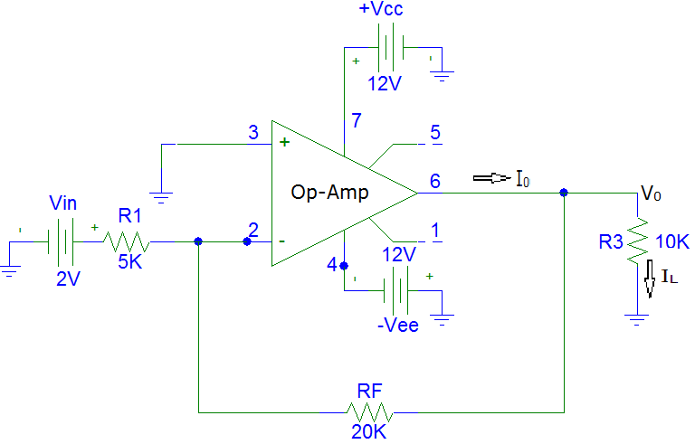  Fig. 1(b) | C01 | (08)
 | c) |  | With a neat sketch explain the technique adopted in 741 for nulling the input offset voltage and current. | C01 | (04)
2 | a) |  | A LF353 BIFET Op-Amp is used in a non inverting amplifier with a voltage gain of 100. Calculate the typical output voltage that would result from common mode input with a peak level of 100mV. (From LF353 data sheet CMRR_{Typ} = 100 dB). | C01 | (04)
 | b) |  | Determine the output voltage for the open loop difference amplifier amplifier circuit given in fig. 2.(b), if  i) V_{in1} = 5 µV d.c. and V_{in2} = -7 µV d.c. (both are d.c. input voltage)  ii) V_{in1} = 7.07 mV (rms) and V_{in2} = 14.14 mV (rms) (sine wave a.c. input).  Draw the input and output waveform for both the cases.  Op-amp used is 741 op-amp with a supply voltage of + 15V (open loop gain of op-amp is 2,00,000).  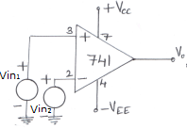  2.(b) | C01 | (08)
 | c) |  | With a neat sketch explain the working of non inverting summing amplifier. Derive an expression for its output voltage. Also discuss the design steps involved in designing the circuit using 741 op-amp and BIFET LF353 op-amp . | C02 | (08)
 |  |  | UNIT – II
3. | a) |  | Using a 741 op-amp, design a high Z_{in} non inverting amplifier to operate with a +36V power supply. The load resistance is 12 KΩ, the lower cut off frequency is to be 150 Hz and the voltage gain is to be 7. Draw the circuit with component values mentioned on it. | C03 | (10)
 | b) |  | The non saturating precision half wave rectifier has to rectify (pass) only positive half cycle of the input voltage. using bipolar Op-amp design a suitable circuit which produces a 5V peak output from a sine wave input with a peak value of 0.5V and the frequency of 1 MHz. Use supply voltage of + 15V. Draw the circuit with component values mentioned on it. | C03 | (06)
 | c) |  | With a neat sketch explain the working of precision rectifier peak detector. | C02 | (04)
4. | a) |  | With a neat sketch explain the working for capacitor coupled voltage follower. Write the steps involved in designing the circuit. | C02 | (05)
 | b) |  | An op-amp dead zone circuit with a 5V peak input is to have unity gain and is to pass the upper half of the positive half cycle of input waveform.  i) Design a suitable circuit using bipolar op-amp. Specify the op-amp and the diodes if the signal frequency ranges from 1 KHz to 33 KHz  ii) If a + 15V supply is used with the circuit, modify the circuit to derive the reference voltage from the supply  iii) Make the dead zone circuit adjustable between 1/3rd and 2/3rd of the peak output voltage by suitable modification.  Draw the circuit diagrams for (i), (ii) and (iii) separately with component values mentioned on it. | C03 | (15)
 |  |  | UNIT – III
5. | a) |  | Design a second order high pass active filter with cut-off frequency of 1KHz using 741 op-amp. | CO2 | (06)
 | b) |  | With a circuit diagram and waveform explain the principle of operation of triangular generator using op-amp and derive the expression for frequency of oscillation. | CO3 | (10)
 | c) |  | Mention the advantages of active filters over passive filters. | CO2 | (04)
6. | a) |  | Design an astable multivibrator to have 4KHz output with an amplitude of ±14V with ±15V supply using 741 opamp. | CO2 | (06)
 | b) |  | Design a second order low pass active filter using 741 op-amp to have cut-off frequency of 5KHz. Draw the circuit. | CO2 | (06)
 | c) |  | With a circuit diagram and waveform explain the principle of operation of RC phase oscillator using op-amp and derive the expression for frequency of oscillation. | CO2 | (08)
 |  |  | UNIT – IV
7. |  | a) | Design a non inverting voltage level detector to have V_{UT} = 12 and V_{LT} = 8V. Assume that + V_{sat} = + 15V. Sketch the circuit with component values mentioned on it. | C03 | (05)
 |  | b) | With a neat sketch explain the working of a window detector. | C02 | (05)
 |  | c) | Discuss the effect of stray capacitance on op-amp circuit stability. Write the equation to determine the value of stray capacitance that might produce circuit instability. Also discuss the methods for compensating stray capacitance effects. | C02 | (10)
8. |  | a) | With a neat sketch show how a voltage level detector with independent adjustment of hysteresis and center voltage can be used to design a battery voltage level monitoring system. Explain the operation of battery voltage level monitoring system. | C02 | (10)
 |  | b) | Using a 709 op-amp, design an inverting amplifier to have A_{V} = 50 and V_{S} = 50 mV. Select suitable compensating components. Refer fig. 8(b)(i) and 8(b)(ii) for selecting components for the circuit designed (From 709 data sheet I_{B(max)} = 200 nA)  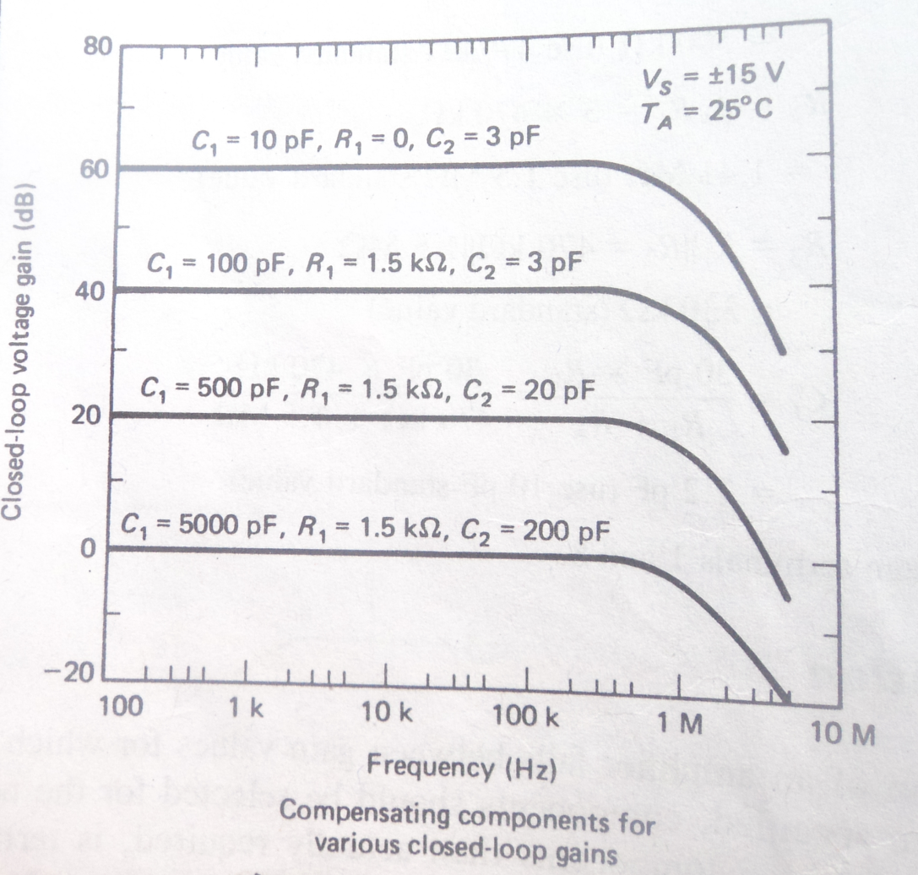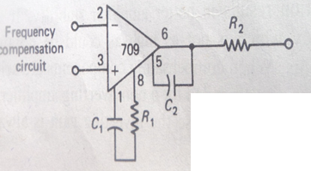  Fig 8(b)(i) fig. 8(b)(ii) | C02 | (06)
 |  | c) | List at least four precaution that should be observed for operational amplifier circuit stability. | C02 | (04)
 |  |  | UNIT – V
9. |  | a) | Design an integrator having gain limiting frequency f_{a} = 200 Hz and highest input signal frequency f_{b} = 2000 Hz using 741 op-amp. Draw the circuit diagram with component values mentioned on it. | C03 | (10)
 |  | b) | Briefly explain the typical performance parameters for a voltage regulator. | C02 | (05)
 |  | c) | With a neat sketch explain how a pulse stretcher can be designed with a monostable multivibrator using 555 timer. | C02 | (05)
10. |  | a) | With a neat sketch explain the working of low voltage DC voltmeter and low voltage AC voltmeter. | C02 | (12)
 |  | b) | Design an astable multivibrator using 555 timer for a free running frequency of 3 KHz. The multivibrator is to have a duty cycle of 50%. Draw the circuit diagram with component values mentioned on it. | C03 | (08)

********************

